Capability 2: Numeracy

Numeracy involves recognising and understanding the role of mathematics in the world and having the ability to
Work out the total cost and show your workings here:

use mathematical knowledge and skills purposefully.

Numeracy capability is organised into 6 elements:
How much change will you get?
Show your workings here:

Estimating and calculating with whole numbers

- Recognising and using patterns and relationships
- Using fractions, decimals, percentages, ratios and rates
- Using spatial reasoning
- Interpreting statistical information
- Using measurement

Estimating and calculating with whole numbers

Activity
Can you use whole numbers (such as 8, 1242,
306) for everyday purchasing and budgeting using the following strategies?
- Mentally – that is, working it out in your head
For example: 25 – 7 = ?
- Written – that is, writing down problems and working them out using equations

For example:
You have to $20 to buy a few groceries for a barbeque. You need to buy the following
- Can you use digital strategies – that is, working out sums using technology, such as a calculator?
Use a calculator to find out the answer to this problem: 3754/27 x 9 – 488 =

Recognising and using patterns and relationships

Activity
Can you identify trends?

For example:
- What is the cost of the bus-fare for a student
during off-peak times?
- For approximately what period of time has the fare been steady?
- Based on this information, do you think the bus-fare will increase, decrease or remain steady over the next 12 months? Why do you think so?

items:

- Tomato sauce $3.69
- Bread $2.50
- Cheese $4.85
- BBQ sausages $6.30
You also need to be able to use a wide range of rules and relationships to continue and to predict patterns.

A simple example is:
Fill in the missing numbers in the following sequence:

3 6 9 15

Capability 2: Numeracy

Using fractions, decimals, percentages, ratios and rates
What do fractions and decimals mean and how
are they represented as ratios, rates and percentages?
How can you apply this knowledge and understanding in real life situations and to solve problems?

Here’s an example:
You cut a cake into 6 pieces. 2 people eat a piece of cake.
What fraction of the cake is left?
2/6 (2 pieces of the cake eaten out of 6) = 1/3

What percentage of the cake is left?

Activity
Can you solve problems using symmetry, shapes and angles?
- Choose a sport.

- What kind of surface is this sport played on?

- What are the dimensions of the playing field for this sport?

- Does the playing field have a particular shape? What is it? Why?

33.333333%

If you offer a piece of cake to 6 friends, what is the ratio of cake to people? 1:6

Using spatial reasoning

Activity
Can you visualise, identify and sort
2-dimensional and 3-dimensional objects? Which is the 3D object?

- Is symmetry important? Why or why not?

- Does the playing field have any shapes marked out on it? What are they? Why?

- Are there any angles that are important in this game? If so, give one example and explain why it’s important.

Capability 2: Numeracy

Activity
Can you interpret maps and diagrams using scales, legends and directional language to identify and describe routes and locations?
- Use Google Maps, a GPS or a Street Directory to find the street that you live on.
- What is the distance between the street and the location that you’re at now? Use the scale on the map to estimate the number of kilometres between the two locations.

Interpreting statistical information
Statistical information is represented through solving problems that includes data:

collection
- records
- displays
- comparisons
- evaluation

Once you have these different types of data,

you need to evaluate how effective they are.

- Which general direction do you need to go from your current location to the street that you live on? (Eg: north; south-west…)

- Without using the map, explain to your Case Manager, teacher or another person how to get to your street from your current location. Are there key landmarks along the way?

When we have collected data, from a survey for example, we need to summarise it.
A common way to do this is to use graphs, such as line graphs, bar graphs and pie charts.

Activity
- Look at the SACE pie chart.
- What does it tell you?
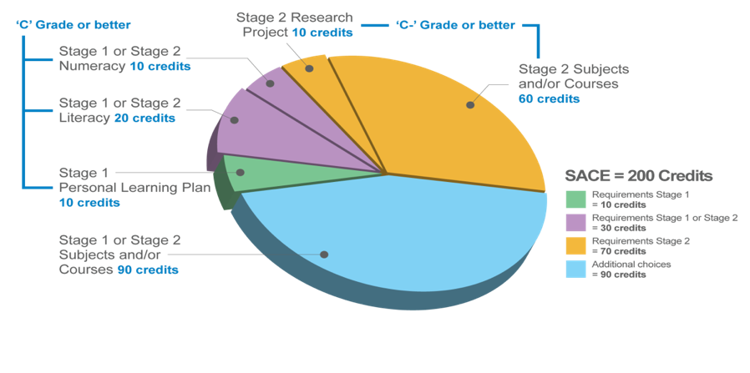
- Explain to your Case Manager, teacher or to another person what the pie chart means.
Personal Learning Plan (PLP) Assessment Task 1 My Capabilities
8

Capability 2: Numeracy
Using measurement

Measurement involves:
- Estimating (a close guess of the actual value, usually with some thought or calculation involved)
- Measuring (measurement is a number that shows the size or amount of something. In Australia, we generally use the metric system of measurement (for example: centimetres, kilograms, hectares, litres….)
- Comparing (knowing if one measurement is the same as, smaller than or larger than another measurement or number)
- Calculating (to work out an answer, usually by adding, multiplying etc)

…as it relates to using metric units of measurement for
- Length (how long, tall or far apart
something is)
- Area (the size of a surface)
- Volume (the amount of 3-dimentsional space that an object occupies)
- Capacity (the amount that something
can hold)
- Time (reading clocks and converting time, such as 12 hour to 24 hour clock, identify and sequence dates and events using a calendar, and creating or reading timetables)
Mass (how much matter is in an object - mass is measured by weighing something, although mass and weight are not the same thing)

…as it relates to using metric units of measurement for
- Length (how long, tall or far apart
something is)
- Area (the size of a surface)
- Volume (the amount of 3-dimentsional space that an object occupies)
- Capacity (the amount that something
can hold)
- Time (reading clocks and converting time, such as 12 hour to 24 hour clock, identify and sequence dates and events using a calendar, and creating or reading timetables)
- Mass (how much matter is in an object - mass is measured by weighing something, although mass and weight are not the same thing)

Activity
Which parts of this capability do you feel that you can demonstrate successfully?
- Estimating and calculating with whole
numbers
- Recognising and using patterns and relationships
- Using fractions, decimals, percentages,
ratios and rates
- Using spatial reasoning
- Interpreting statistical information
- Using measurement

