Future Farmers of America

Predictions: Top 5 Agriculture Careers in 2020
By Abbey Nickel|August 31st, 2017|Career Pathways, Career Success, Employment Skills, The Feed
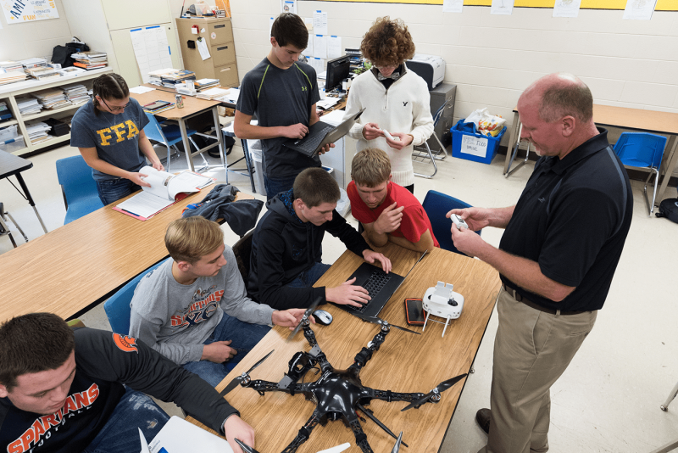

Advances in science and technology are keeping farmers and agriculture professionals on top of their game, and by 2020 there will be even higher demand for skilled individuals in agriculture than there is today. Here are our predicted top five careers in agriculture in 2020.
- Drone Technologists. Show farmers how to increase yields and reduce crop damage using sensors, robotics and images from the air. Similar: Crop Scout, Aerial Applicator / Agricultural Pilot
- Hydrologists. Protect the environment and promote sustainability while helping supply the world with clean, safe water.
- Agriculture Communicators. Share the story of agriculture and engage the public to better understand it. The industry needs to advocate now more than ever.
- Food Scientists. Improve food products and create new ones using scientific principles that help maintain a wholesome food supply.
- Precision Agriculture Technologists. Teach farmers how to work better, not harder, by using new technologies that increase crop yields and decrease inputs.
Erika Osmundson, director of marketing and communications for AgCareers.com, says while many people perceive agriculture as “old fashioned,” advancements in the use of technology have created crucial, innovative solutions in many aspects of agriculture.
“The increasing demand for agriculture to grow more food with less leads to significant opportunities in science and research to help us meet this demand while preserving our natural resources,” she says.
Also in high demand are research scientists, agronomists, veterinarians, salespeople, finance experts, information technologists, electricians and mechanics – just to name a few.
Visit AgExplorer.com for details on these careers and use the career finder assessment to discover which career matches your interests.

https://www.ffa.org/career-success/predictions-top-5-agriculture-careers-in-2020/

