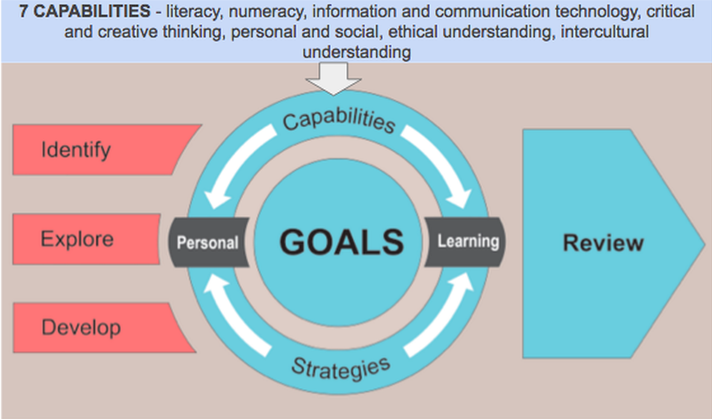
Understanding the 7 Capabilities
Literacy: Skills to understand and interpret a variety of texts and people in a range of different situations and countries. Literacy is an every-century skill. Literacy is reading, remembering, writing, understanding, creating, and speaking.
Numeracy: Knowledge to use Mathematics to effectively interpret information and solve problems. To have good numeracy skills means you can reason and work with numbers, problem solve, and think logically. By developing your numeracy skills, you will become an active and informed citizen.
Information and Communication Technology: Use current and emerging technologies and understand their impact on society and the workplace. In our digital age, it is important to be a logical thinker, adaptable to change, and a team player. Technology skills allow you to communicate locally and globally.
Critical and Creative Thinking: Use critical and creative thinking skills to identify and analyse complex topics and questions. Critical and creative thinking skills are some of the most sought-after skills across every workplace. You will learn to think broadly and deeply using reason, logic, imagination, and innovation.
Personal and Social: Confidence, self-discipline and independence. The ability to work in a team and being resilient to deal with challenging situations. Being aware of your own and others emotional, mental, and spiritual wellbeing. Having a sense of self-worth, being optimistic, empathetic, and resilient. The personal and social capability is a foundation for the intellectually curious.
Ethical Understanding: A deep understanding of ethical issues and how to manage them. Cultural, social, and environmental transformations are changing the world. Ethical understanding is exploring global and local interactions and engaging with complex issues. Navigating through a world of competing values, supporting you as you transition from school to your chosen career path.
Intercultural Understanding: Appreciating and respecting other people’s social and cultural backgrounds and learn about the diversity of our nation and the world. Learning your own values, languages, beliefs, and morals, as well as those of others. Intercultural understanding is an essential part of living in the 21st century. You are encouraged to express empathy, respect, and responsibility.

