Name: __________________________________

Work Health Safety Activities

WHS 1

Why do we wear PPE? https://www.youtube.com/watch?v=KgkvxUtczLA

Watch the clip and write your answers to these questions on this sheet.

- What does PPE stand for?

___________________________________________________________________________________

- List the 3 items of PPE that you saw in this clip.

- __________________________________________________________

- __________________________________________________________

- __________________________________________________________

- Give an example of a job where you would need each item of PPE. (You need to come up with a different job for each item.)

- __________________________________________________________

- __________________________________________________________

- __________________________________________________________

- Give an example of a hazard that the PPE could protect the worker from for each of the jobs you have suggested in question 3.

- __________________________________________________________

- __________________________________________________________

- __________________________________________________________

WHS 2
Thank god you’re here http://www.youtube.com/watch?v=kF9jXZDYCxE

Watch the clip and write your answers to these questions on this sheet.
List five things that the safety inspectors point out as being wrong at the worksite.
1. ________________________________________________________________________________
2. ________________________________________________________________________________
3. ________________________________________________________________________________
4. ________________________________________________________________________________
5. ________________________________________________________________________________
Add one more thing that you think is wrong at the worksite that the safety inspectors missed.

1. ________________________________________________________________________________

WHS 3
Grim Reaper http://www.youtube.com/watch?v=Fcst9n5bgh4

Watch the clip and write your answers to these questions on this sheet.

- List three items of PPE that the workers are wearing.

1. __________________________________________________________

2. __________________________________________________________

3. __________________________________________________________

- What unsafe things does Ricky do?
- With the chainsaw?

__________________________________________________________

- In his car?

__________________________________________________________

- With his clothing?

__________________________________________________________

- List five things that Ricky or the supervisor could have done differently that may have prevented the workplace accident?

- _________________________________________________________________________

_________________________________________________________________________

- _________________________________________________________________________

_________________________________________________________________________

- _________________________________________________________________________

_________________________________________________________________________

- _________________________________________________________________________

_________________________________________________________________________

- _________________________________________________________________________

_________________________________________________________________________

WHS 4

WorkSafe Victoria

Watch each short clip and write your answers to these questions on this sheet.
Watch the clip called Every 12 Minutes
- Why was the employer worried about the visit of the WorkSafe Inspector?

___________________________________________________________________________________

- What should the employer have done to ensure his workers are safe?

___________________________________________________________________________________

- In South Australia we have SafeWork SA. Their inspectors visit workplaces and events all over South Australia. What do you think that their main role is when they visit a workplace?

___________________________________________________________________________________
Watch the Young Worker clips – Nail Gun, Kitchen, Bakery, Nick’s Story, Beth’s Story
- What do you think is the main message that WorkSafe is trying to get across to young workers?

___________________________________________________________________________________

- For each clip, name two strategies that could have prevented these incidents.
Nail Gun 1. ____________________________________________________________________
2. ____________________________________________________________________
Kitchen 1. ____________________________________________________________________
2. ____________________________________________________________________
Bakery 1. ____________________________________________________________________
2. ____________________________________________________________________
Nick’s Story 1. ____________________________________________________________________
2. ____________________________________________________________________
Beth’s Story 1. ____________________________________________________________________
2. ____________________________________________________________________
Watch the clip Supervisors TV Commercial - Construction/Manufacturing
- What do you think is the main message that WorkSafe is trying to get across to supervisors?
___________________________________________________________________________________

WHS 5
Complete online Safety Tutorial Quiz
https://www.safework.sa.gov.au/resources/online-activities/introduction-to-safety-tutorial

- Read through each subtopic as outlined below
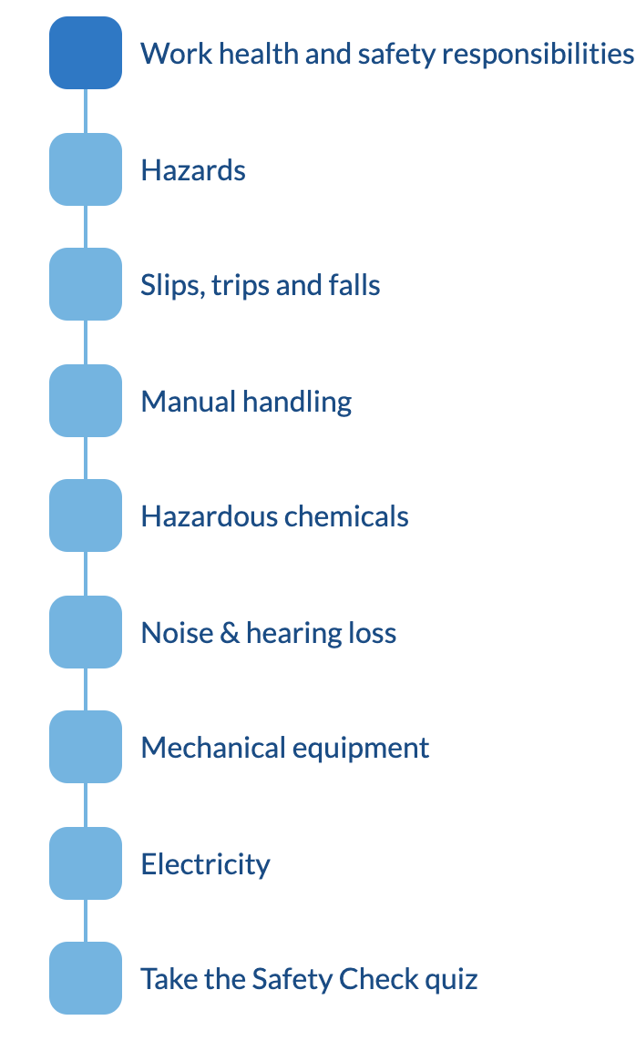

- Complete the Safety check quiz, and screenshot your 100% correct quiz result. You must get all questions right and provide proof.

